Business Overview

Core Activities: The club focuses on training sessions for different age groups, organizing friendly matches and participating in competitive leagues. We also host soccer camps and clinics.

Members: Our members range from young children starting out in soccer to teenagers and young adults playing at competitive levels. We categorize members by age groups and skill levels.

Staff: Our team includes coaches, assistant coaches, fitness trainers, a physiotherapist, and administrative personnel such as a club manager, membership coordinator, and financial officer.

Facilities: The club owns a soccer field, training equipment, a clubhouse with locker rooms, and an office for administrative tasks.

Entities, Attributes, and Relationships

To effectively manage our operations and maintain detailed records, the database should encapsulate the following entities, attributes, and relationships:

Entities and Attributes

Members

Attributes: Member ID, Name, Date of Birth, Contact Information, Emergency Contact, Membership Date, Membership Type (e.g., youth, adult, competitive), Team Assignment

Teams

Attributes: Team ID, Age Group, Skill Level, Coach ID

Staff

Attributes: Employee ID, Name, Role (e.g., Coach, Assistant Coach, Fitness Trainer), Contact Information, Qualifications, Schedule

Matches

Attributes: Match ID, Date, Location, Opponent, Team ID, Result, Highlights

Training Sessions

Attributes: Session ID, Date, Time, Location, Coach ID, Team ID, Focus Areas

Equipment

Attributes: Equipment ID, Name, Quantity, Condition, Purchase Date, Last Maintenance Date

Facilities

Attributes: Facility ID, Name, Type (e.g., Field, Clubhouse, Office), Maintenance Schedule

Relationships

Members to Teams: Many-to-Many (Members can be assigned to multiple teams based on age group and skill level; teams comprise multiple members)

Teams to Coaches: Many-to-One (Multiple teams can be coached by the same coach, but each team has one main coach)

Matches to Teams: One-to-Many (A team can have multiple matches but a match involves one or two teams)

Training Sessions to Teams: One-to-Many (A team has multiple training sessions, but each session is designed for one team)

Equipment to Training Sessions: Many-to-Many (Training sessions require various equipment, and equipment can be used in multiple sessions)

Additional Requirements

Security and Privacy: It's essential to protect the personal information of our members and staff, adhering to data protection regulations.

Scalability: The database must be scalable to accommodate the club's growth in members, staff, and activities.

Reporting and Analytics: Capabilities for generating reports on membership trends, team performance, match outcomes, and financial health are necessary for strategic planning.

By addressing these needs, the database created by the MIST 4610 class will enable our soccer club to streamline operations, enhance member engagement, and improve overall performance.

**Data Dictionary**

Table: Members

| Column Name | Description | Data Type | Size | Format | Key |
| --- | --- | --- | --- | --- | --- |
| memberID | Unique number assigned to members | INT | 8 | 123456789 | PK |
| memberName | The name of the club member | VARCHAR | 45 | abc |  |
| memberDOB | The birthday of the member | Date | 2,2,4 | 00-00-0000 |  |
| contactInfo | Phone number of member | INT | 9 | 1234567890 |  |
| Emergency contact | Phone number of a members listed emergency contact | INT | 9 | 1234567890 |  |
| teamID | The unique number that associates a team | INT | 8 | 123456789 | FK |

**Table:** Teams

| Column Name | Description | Data Type | Size | Format | Key |
| --- | --- | --- | --- | --- | --- |
| teamID | The unique number that associates a team | INT | 8 | 12345678 | PK |
| ageGroup | The labels age group associated with a particular team | VARCHAR | 45 | U-15 |  |
| skillLevel | A description of the skill of a team | VARCHAR | 45 | advanced |  |
| coachID | The unique number that associates a coach | INT | 9 | 1234567890 | FK |

**Table:** Coaches

| Column Name | Description | Data Type | Size | Format | Key |
| --- | --- | --- | --- | --- | --- |
| coachID | The unique number that associates a coach | INT | 8 | 12345678 | PK |
| staffName | The name of the staffmember | VARCHAR | 45 | abc |  |
| contactInfo | The staff members phone number | INT | 9 | 1234567890 |  |
| yearsOfExperiance | The number of years they have coached for | INT | 2 | 12 |  |
| MedicalStaffId | Same number as coach ID, howeer, only some coaches are also medical staff | INT | 8 | 12345678 | FK |

**Table:** Matches

| Column Name | Description | Data Type | Size | Format | Key |
| --- | --- | --- | --- | --- | --- |
| matchID | The unique number that associates a match | INT | 8 | 12345678 | PK |
| matchDate | The date of a set match | DATETIME | 2,2,4 | 00-00-0000 |  |
| matchLocation | Where the match will be played | VARCHAR | 45 | abc |  |
| opponent | Who the team is playing | VARCHAR | 45 | abc |  |
| result | The outcome of the match | VARCHAR | 1 | W |  |
| facilityID | The unique number that associates a facility | INT | 8 | 12345678 | FK |
| teamID | The unique number that associates a team | INT | 8 | 12345678 | FK |

**Table:** Training Facilities

| Column Name | Description | Data Type | Size | Format | Key |
| --- | --- | --- | --- | --- | --- |
| facilityID | The unique number that associates a facility | INT | 8 | 12345678 | PK |
| facilityName | The name of the facility | VARCHAR | 45 | abc |  |
| facilityType | A classification of the type of facility | VARCHAR | 45 | abc |  |
| location | The address of the facility | VARCHAR | 60 | abc |  |

**Table:** Training Sessions

| Column Name | Description | Data Type | Size | Format | Key |
| --- | --- | --- | --- | --- | --- |
| sessionID | The unique number that associates a session | INT | 8 | 12345678 | PK |
| Date | The date of a set training session | DATETIME | 2,2,4 | 00-00-0000 |  |
| Location | Where the practice will be held | VARCHAR | 45 | abc |  |
| time | What time the practice will be | INT | 4 | 123 |  |
| facilityID | The unique number that associates a facility | INT | 8 | 12345678 | FK |
| teamID | The unique number that associates a team | INT | 8 | 12345678 | FK |

**Table:** Injuries

| Column Name | Description | Data Type | Size | Format | Key |
| --- | --- | --- | --- | --- | --- |
| InjuryID | Unique number assigned to each injury for classification | INT | 8 | 12345678 | PK |
| memberID | Unique number assigned to members | INT | 8 | 12345678 | FK |
| injuryType | The worded classification of an injury | VARCHAR | 45 | abc | FK |
| timeOfInjury | Time of injury occurance | VARCHAR | 45 | abc |  |
| injuryLocation | Where the injury took place | VARCHAR | 45 | abc |  |

**Table:** Injury Type

| Column Name | Description | Data Type | Size | Format | Key |
| --- | --- | --- | --- | --- | --- |
| InjuryID | Unique number assigned to each injury for classification | INT | 8 | 12345678 | PK |
| injuryDescription | Worded description of an injury | VARCHAR | 45 | abc |  |
| injuryType | The worded classification of an injury | VARCHAR | 45 | abc | FK |

**Table:** Equipment

| Column Name | Description | Data Type | Size | Format | Key |
| --- | --- | --- | --- | --- | --- |
| equipmentID | Unique number assigned to each piece of equipment | INT | 8 | 12345678 | PK |
| datePurchased | Date of when the equipment was bought | DATE | 2-2-4 | 00-00-0000 |  |
| location | What facility the equipment is located | VARCHAR | 45 | abc |  |
| facilityID | Unique number assigned to each facility | INT | 8 | 12345678 | FK |

**Table:** Suppliers

| Column Name | Description | Data Type | Size | Format | Key |
| --- | --- | --- | --- | --- | --- |
| supplierID | Unique number assigned to each supplying company | INT | 8 | 12345678 | PK |
| orderDate | Date of when the order was placed | DATE | 2-2-4 | 00-00-0000 |  |
| address | Address of facility | VARCHAR | 45 | abc |  |
| phone | Phone number of facility | INT | 9 | 123456789 |  |
| orderStatus | Displays order status | VARCHAR | 45 | abc |  |

**Table:** Uniform Orders

| Column Name | Description | Data Type | Size | Format | Key |
| --- | --- | --- | --- | --- | --- |
| productID | Unique number assigned to each product | INT | 8 | 12345678 | PK |
| name | Name of product | VARCHAR | 45 | abc |  |
| type | Classification of product | VARCHAR | 45 | abc |  |
| price | Price of product | INT | 3 | 123 |  |
| quantity | Quantity of product | INT | 3 | 123 |  |
| supplierID | Unique number assigned to each supplying company | INT | 8 | 12345678 | FK |

**Table:** Order Details

| Column Name | Description | Data Type | Size | Format | Key |
| --- | --- | --- | --- | --- | --- |
| productID | Unique number assigned to each product | INT | 8 | 12345678 | FK |
| memberID | Unique number assigned to each product | INT | 8 | 12345678 | FK |
| orderID | Unique number assigned to each order | INT | 8 | 12345678 | PK |
| price | Price of product | INT | 3 | 123 |  |
| purchaseDate | When the product was purchased | DATE | 2,2,4 | 00-00-000 |  |

**Queries**

**Simple**

1. **What are the coach's names and IDs who have more than 20 years of experience Order by years of experience descending.**
   1. SELECT staffName, yearsOfExperience FROM Coaches WHERE yearsOfExperience > 20 ORDER BY yearsOfExperience DESC;

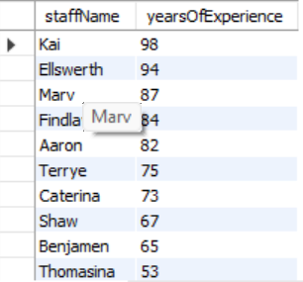

1. **List the equipment ID and date purchased for all equipment at Facility 4**
   1. SELECT equipmentID, datePurchased FROM Equipment WHERE facilityID = 4;

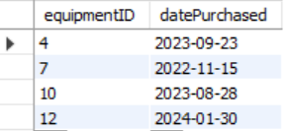

1. **List the team names who have won their match**

SELECT Teams_teamID, matchDate, opponent FROM Matches WHERE result = "win";

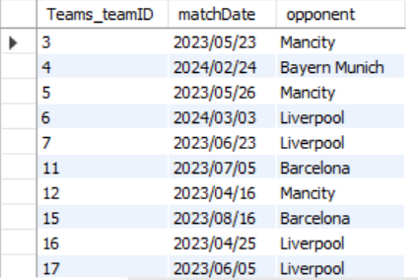

1. **What is the supplier ID and phone number of orders that have been canceled?**

SELECT supplierID, phone FROM Suppliers Where orderStatus = 'Cancelled';

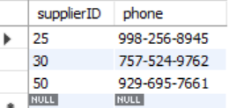

**Complex**

1. **Find the facility name and the total count of equipment in each facility:This query retrieves the total count of equipment in each facility along with the facility name. Managers can use this data to ensure each facility is adequately equipped and to track equipment distribution and usage.**

**Sql code: SELECT `Training Facilities`.`facilityName`, COUNT(`Equipment`.`equipmentID`) AS TotalEquipment**

**FROM `Training Facilities`**

**LEFT JOIN `Equipment` ON `Training Facilities`.`facilityID` = `Equipment`.`facilityID`**

**GROUP BY `Training Facilities`.`facilityName`;**

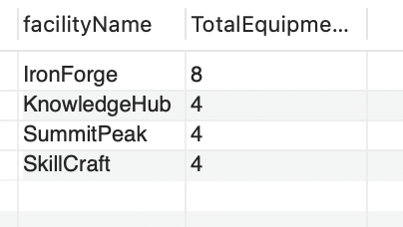

1. **List the top Supplier by Total Order Amount: This information is crucial for evaluating supplier performance, optimizing inventory management, and making strategic procurement decisions, ensuring efficient and cost-effective supply chain operations.**

**Sql code: SELECT Suppliers.supplierID, Suppliers.address, Suppliers.phone,**

**SUM(`Uniform Orders`.price * `Uniform Orders`.quantity) AS TotalOrderAmount**

**FROM Suppliers**

**JOIN `Uniform Orders` ON Suppliers.supplierID = `Uniform Orders`.supplierID**

**GROUP BY Suppliers.supplierID, Suppliers.address, Suppliers.phone**

**ORDER BY TotalOrderAmount DESC**

**LIMIT 1;**

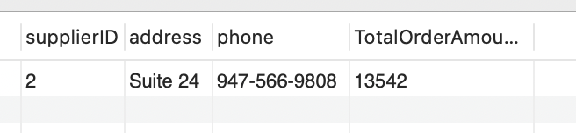

1. Query: Total Number of Injuries by Team:Team-level injury statistics are crucial for assessing the overall injury burden within each team. Team managers and coaches can use this information to evaluate the effectiveness of their training programs, identify teams at higher risk of injuries, and allocate resources for injury prevention measures accordingly.

Sql code: SELECT `Teams`.`teamID`, COUNT(`Injuries`.`injuryID`) AS TotalInjuries

FROM `Teams`

LEFT JOIN `Members` ON `Teams`.`teamID` = `Members`.`teamID`

LEFT JOIN `Injuries` ON `Members`.`memberID` = `Injuries`.`Members_memberID`

GROUP BY `Teams`.`teamID`;

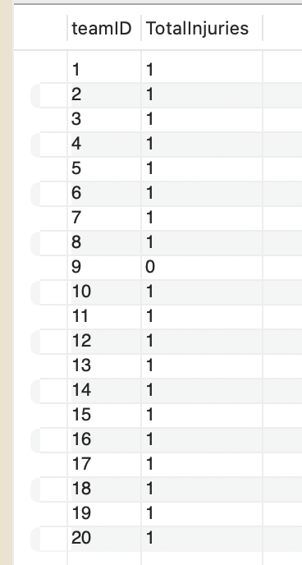

1. **Query: Determine the total number of matches played by each team: This query counts the total number of matches played by each team. It utilizes a left join between the Teams and Matches tables to capture all teams, even if they haven't played any matches yet.**

**Sql code: SELECT Teams.teamID, COUNT(Matches.matchID) AS TotalMatches**

**FROM Teams**

**LEFT JOIN Matches ON Teams.teamID = Matches.Teams_teamID**

**GROUP BY Teams.teamID;**

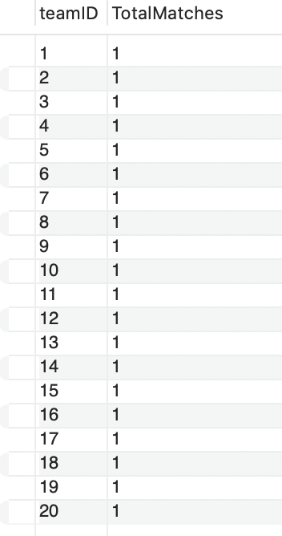

1. Query: Identify teams with more than 2 members aged below 18.

Description: This query identifies teams with more than 10 members aged below 18. Managers may be interested in this to ensure compliance with age restrictions in leagues or to address concerns related to youth player development and supervision.

Sql Code: SELECT Teams.teamID, COUNT(Members.memberID) AS TotalMembers

FROM Teams

JOIN Members ON Teams.teamID = Members.teamID

WHERE YEAR(CURDATE()) - YEAR(Members.memberDOB) < 18

GROUP BY Teams.teamID

HAVING TotalMembers > 2;

Result for query 5: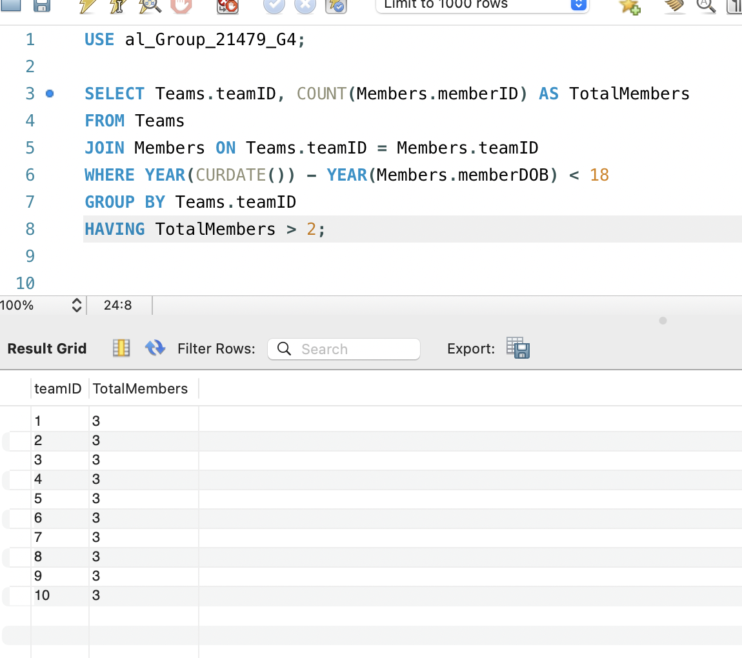

1. Query: List all teams along with the count of members and the average age of members in each team.

Sql code: SELECT Teams.teamID, COUNT(Members.memberID) AS TotalMembers, AVG(YEAR(CURDATE()) - YEAR(Members.memberDOB)) AS AvgAge

FROM Teams

LEFT JOIN Members ON Teams.teamID = Members.teamID

GROUP BY Teams.teamID;

